**1) Steps for creating a particular IP address ELASTIC IP address :-**

a**. First sing in to the aws console.**

**b. Make sure the region is set to U.S.East(N.virginia) this is the region .**

**c. Search for Elastic IP interface**

**d. Type Elastic IP in the AWS management console search box and then click Cloudwatch.**

**e. In the Elastic IP go to create IP.**

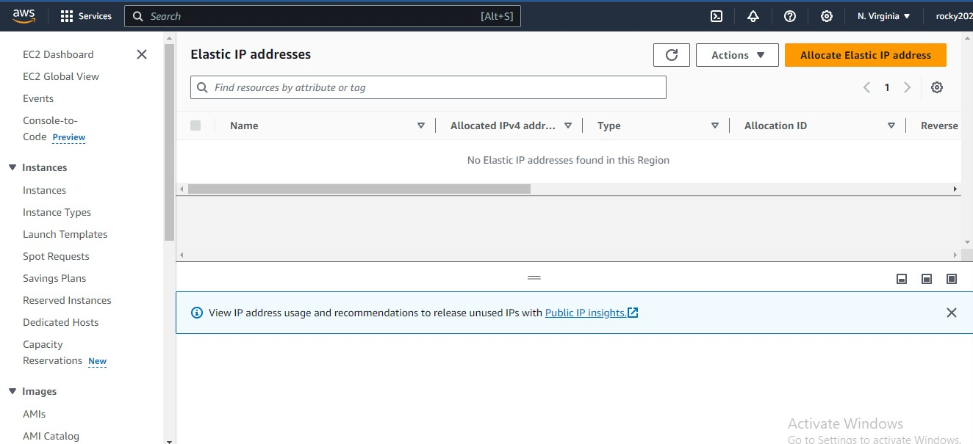

**2) Creating new Elastic IP.**

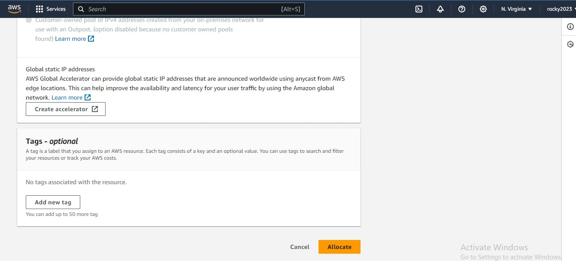

**3) Create and allocate to instance which want that particular IP.**

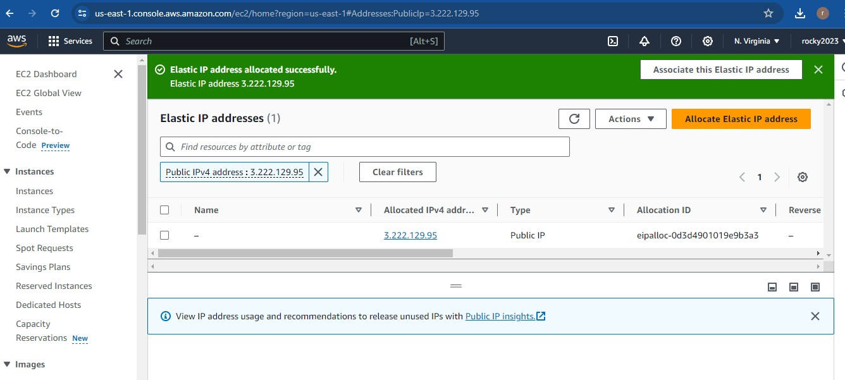

**4) Associate to particular instance.**

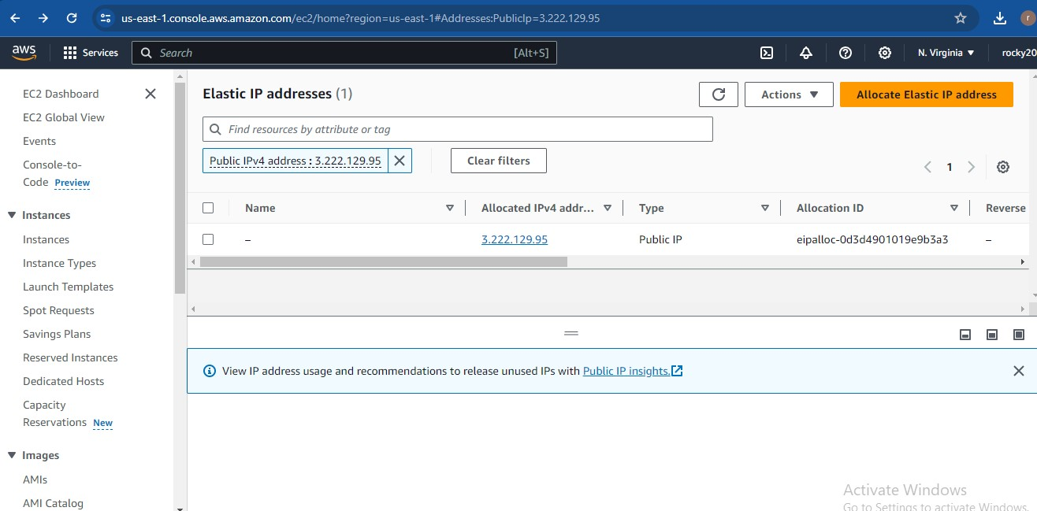

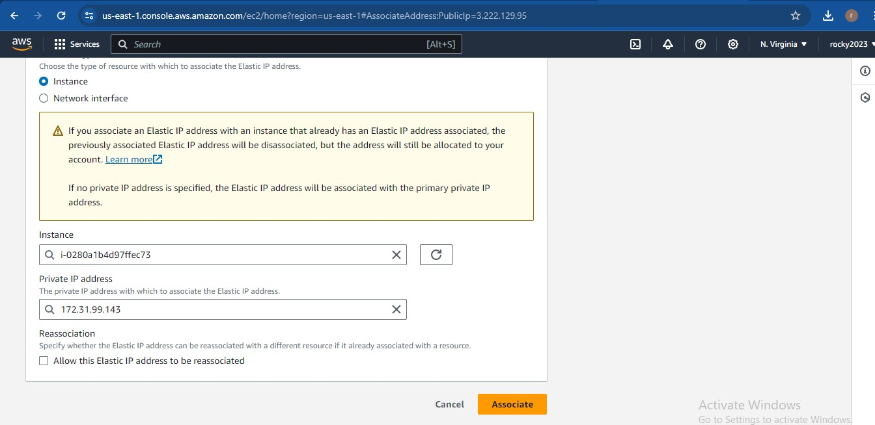

**5) Elastic ip address associated successfully**.

